C:\Users\burkdani\Downloads\MSU-Wordmark-Green-CMYK.epsCTBTO-logo-Short-Engl-White.eps

Calibration Methodology Software Users Guide

1Daniel Burk, 1Kevin Mackey, 2Hans Hartse, 1Elanor Rappollee

1Department of Geological Sciences, Michigan State University 2Los Alamos National Laboratory, Los Alamos, NM

**Abstract.** This document briefly describes the calibration methodology, and more importantly, describes how to use the software for calibrating a seismic station. The calibration methodology may be applied to any electro-mechanical seismometer model in which the pendulum mass is visible to the laser position sensor.

# Introduction

The electromechanical seismometer may be calibrated by using several alternative methods, such as co-location or through impulse response and lots of math equations. The result is acceptable enough, but requires you to think through the process, and ensure that the measurement variables are close enough to theoretical as to not cause a problem. In essence the product is generally a measurement of calibration in terms of volts divided by velocity (meters/second.). Most existing methods measure this indirectly, such as by calculating the induced force from a calibration coil, and then calculating the resulting motion based on a calculated interpretation of motor constant, spring force, etcetera. It generally requires the estimation of many variables with many possibilities for error. The following method reduces that error by directly measuring the seismometer output, and by comparing it to a direct measure of seismometer mass deflection. Thus, the measured variables are reduced to a minimum. (Figure 1 is a cartoon that illustrates the variables. )

# Program setup

The calibration software package runs on Python and uses the Obspy package for its seismic processing, and this code must first be installed on the computer. Both Python and Obspy are open-source code, so they are freely available for download from the internet. You must choose the appropriate package for your operating system. Our calibration software has been tested on Windows 7 and Windows 8 computers, on both the 32-bit and 64-bit version. Once the software is installed, you will need to download the Sigcal calibration software from Github and install that onto the computer. Lastly, you will need to edit some system path settings. Here is a brief rundown of the procedure.

#### Downloading Python

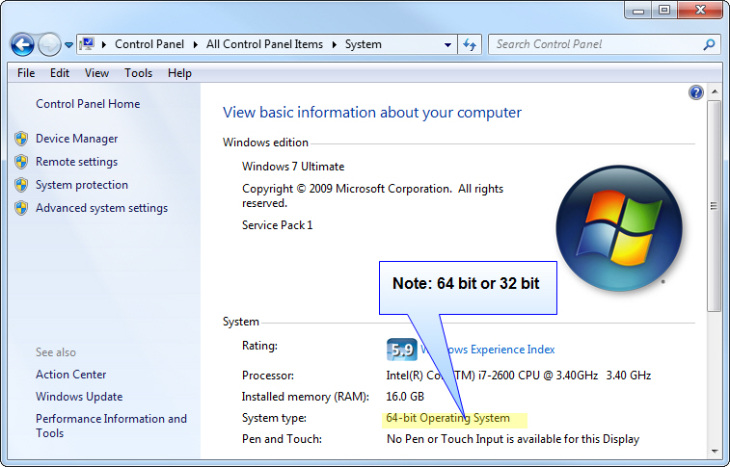

The easiest method for installing the Python software is to use the Anaconda software bundle from continuum.io, who offers this complimentary service as a way to support their other web products. First, identify your operating system by opening the System control panel of your computer. We will use this window later, when we modify paths in the Advanced System Settings to set our operating environment.

Note: In this case, the operating system is Windows 64-bit operating system.

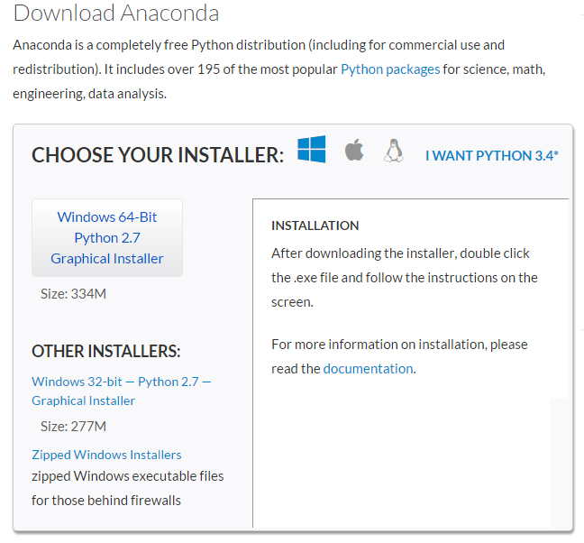

Once identified, go to the website <http://continuum.io/downloads> to download the correct Anaconda installation package. If you have a 32-bit operating system, choose the Windows 32-bit graphical installer.

Choose to install software for “All Users”. This is important because some of these procedures are path dependent.

Once Anaconda is installed, you will have several new development tools available for writing scientific software. There is a graphical package called iPython that is useful for development. There are many useful resources on the internet for teaching how to utilize these resources, which are comparable to the scientific processing power of Matlab. However teaching these tools is beyond the scope of this manual.

#### Installing Obspy

Obspy is the seismic processing software that is used to handle seismic data files and create the SAC poles & zeroes calibration file. This file will describe the frequency response of the seismometer, so that researchers can use the seismic data with more advanced analysis techniques, such as waveform inversion and synthetic seismograms.

Be sure to have your computer connected to a reliable internet connection before starting this next step. Once you have Anaconda installed, the installation of Obspy should be rather straightforward. Go to a command prompt window and type:

C:\> conda install –c obspy obspy

This will install Obspy and all related software modules, except for our calibration software that we will install in just a few minutes.

#### Downloading Sigcal

The Sigcal seismic calibration software is downloadable from Github at the following URL:

<https://github.com/tychoaussie/Sigcal_v1.git>

There, you can choose to download the repository as a ZIP file. Located within the repository is a directory called Sigscript. This directory contains the Python scripts that form the core of the analysis package. Place a copy of this directory into C:/Anaconda

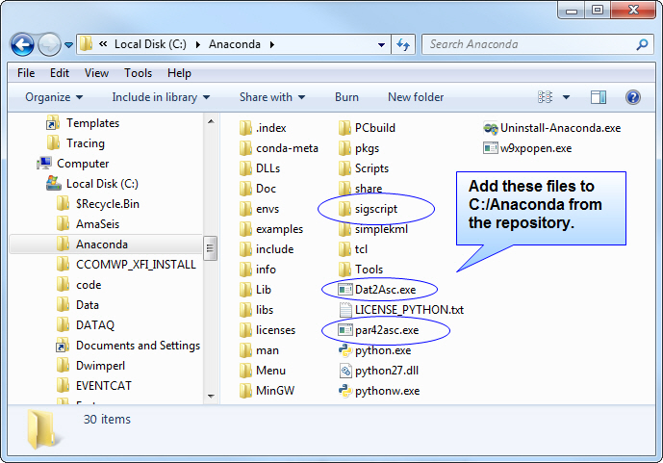Next, find the following the two executable files DAT2ASC.exe” and “PAR42ASC.EXE” within the ZIP file under Symres Utilities, and place a copy of them into the directory C:/Anadonca. They are data converters used by the software. Once completed, you should see the files within the directory like this:

#### Setting up the system environment variables

##### Path:

Once the Sigcal scripts have been installed, it is time to edit system variables. We need to edit the path variable. Go to the control panel, and find the “system” page, as shown in figure 1.

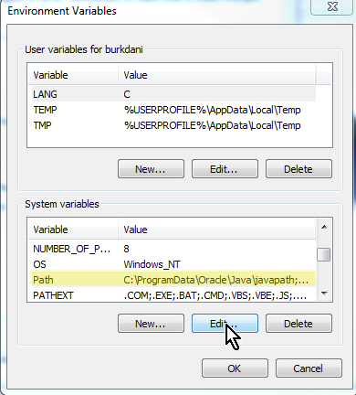Click on the icon, on the left of the panel called “Advanced system settings”, and choose the Environment Variables button. Scroll down through the system variables to the variable called “Path” and select it by pressing Edit. We need to add the following string to the end of the path:

;C:\Anadonca\Python.exe;C:\Anaconda\sigscript

This will enable the command shell to find the Python executable as well as our scripts and batch files, no matter which working directory we are in when using the command line prompt.

##### 

#### Fix the file associations

Sometimes it is necessary to inform the Windows operating system that a Python script is supposed to be opened with Python language interpreter. Otherwise it will simply open the script in a text editor. To accomplish this, it is necessary to set associations for the python file. Go to the search programs tab and type “associations” to open the set associations dialog. Scroll down to find the .py file extension, and choose the default program to be “python.exe”.

At this point, we should have an operational system:

* We have downloaded and installed Anaconda, which includes Python.
* We have installed Obspy via Anaconda.
* We have retrieved the Sigcal software from Github and installed the Sigscript folder into the Anaconda directory.
* We have set our environmental variables so that the scripts will run in any directory.
* We have checked and fixed the file associations so that .py scripts are executed by Python.

#### Place a command line prompt onto your desktop

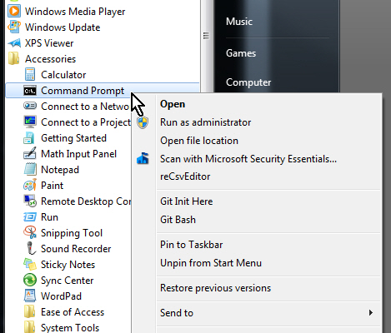Lastly, it is quite handy to place a command line prompt onto your desktop, as the Sigcal software runs within a command shell, rather than in a graphic user interface. The command shell is available under Programs>Accessories>Command Prompt. Right-click on the command prompt, and pin it to your task bar. You can also place it onto the desk top. The command prompt will be the main window for running the calibration software.

# How to make your calibrations accurate

This chapter brings up the question of accuracy. In essence, we are going to “put some marks on our meter stick”. Imagine, if you will, a meter stick manufacturer who is creating wooden meter sticks for the class room. The stick will be one meter long, with graduated marks representing a decimeter, centimeter, and millimeter. How does the manufacturer decide where to place the marks? How do they know that “their” meter is the right length? Well, the manufacturer could compare their unit lengths to some other standard, such as a calibrated meter stick that they purchased from another manufacturer. Yet, they would be placing their trust in the length arbitrarily chosen by the other manufacturer! Woe be to the two meter stick makers who happened to choose each other’s meter sticks as each other’s standard, for their meter would simply be of random length when compared to the rest of the world!

Instead, most calibrations rely on some sort of institute of metrology for the “true measure” of a scientific unit. In the United States, it is called the National Institute of Standards and Technology (NIST). In Russia, the governing body is the Federal Agency on Technical Regulating and Metrology (GOST R). Each country will have their own standards agency, and most are participating members of the International Organization for Standardization (ISO). These institutions keep within their body a ‘gold standard’ for each scientific measurement unit, whether it be unit of length (a meter), unit of time (second), mass (Kilogram), force (Newton), or electromotive force (Volt). They distribute to the rest of the world these “golden meter sticks”, so that instrumentation manufacturers and laboratories can produce measurement devices and measurements which are consistent with one another.

If we are to produce an accurate picture of the instrument response, we must make sure that our own measurement devices are calibrated against these “golden meter sticks”. In the field of metrology, this is known as “traceability” within a calibration. Any laboratory that is in the business of issuing calibration certificates for devices should have current calibration certificates for all of their tools that they employ when making calibrations. It could be a certificate issued by the NIST, ISO, or GOST-R. Or, it could be a certificate issued by a calibration laboratory which used NIST-derived calibrations. In any case, the accuracy of the tool should be traceable, by a paper trail of calibration certificates, to a standard at a national laboratory. If this procedure is not followed, then we are simply putting our trust in some “meter stick” of random length. It might be close, but we won’t really know for sure how close. In other words, we will not be able to state the actual degree of confidence within the calibration.

##### Variables that affect the calibration accuracy

I will restrict the study and use of the word “seismometer” to classical electromechanical seismometers, since this is what the Sigcal method is designed to calibrate. A seismometer is a transducer that converts ground velocity into an electrical signal. A signal, expressed in terms of volts, therefore represents ground velocity, which is expressed in terms of meters per second. When a seismometer is calibrated, what we need to do is make sure that our measurement of the signal output in terms of volts, is really a volt. The same goes with the measurement of the velocity. We need to make sure that we have a good time base for keeping track of time, and a good handle on displacement over that time period. The measurement methods and tools that we use to measure these phenomena must accurately report their results. Therefore, before we begin our measurements, we need to first make sure that our tools are properly calibrated!

##### Calibrating our tools:

The calibration method makes use of several pieces of equipment:

* Seismometer
* Signal generator for exciting the seismometer
* Laser position sensor for tracking displacement.
* Station digitizer for storing the seismometer and laser position sensor signals.

Before the calibration of the seismometer can be accomplished, this equipment must also be calibrated: Preferably to an NIST/ISO traceable standard. However this is not as difficult as it might seem.

###### Calibrating the volt meter:

This might seem like an unusual place to start, but what if our volt meter is inaccurate? If we wish to use a volt meter for verifying our calibration equipment, then it too, must be verified first. This is the nature of ISO traceable calibration metrology. Always be sure your volt meter is accurate by first verifying it against another calibrated source.

###### Calibrating the signal generator:

Because our method only utilizes the signal generator as a way to generate an arbitrary sine –based excitation, this device does not require calibration. It does, however, have to be of sufficient quality as to create a stable oscillation in the seismometer. The signal generator should be able to output good power, with a signal voltage of at least +-10 volts, and no more than 50 ohms output impedance.

###### Calibrating the laser position sensor:

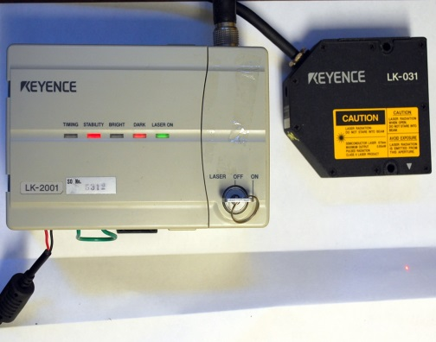This one is important. The calibration method requires us to know precisely how many millivolts of laser signal output represent a micron of displacement. Modern laser position sensors such as the Keyence LKG-32 are digitally controlled, and their gain is adjustable in software. Older systems, such as the Keyence LK-031 also have adjustable gain. In either case, before any laser is employed for calibration use, the gain of the laser position system must be verified.

We have created a simple tool using a digital Vernier caliper to verify displacement. The laser position sensor is attached to the tool, and the voltage of the laser position sensor is recorded for +-5mm. The result should be the gain, in terms of volts / millimeter. This value also represents millivolts per micron. Once the gain is known, we can then with confidence know the measured displacement of our target when the position sensor is utilized for measuring seismometer mass motion.

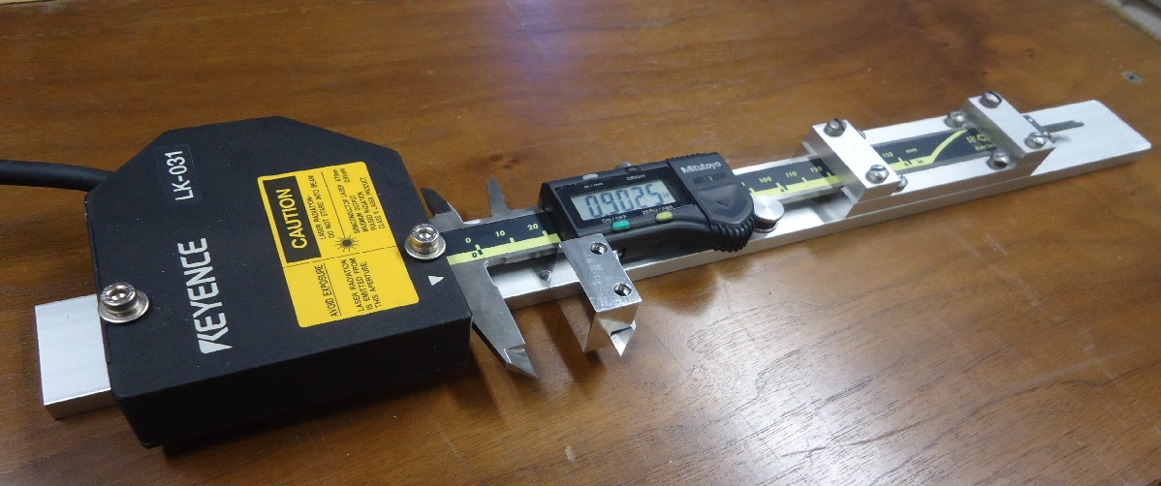

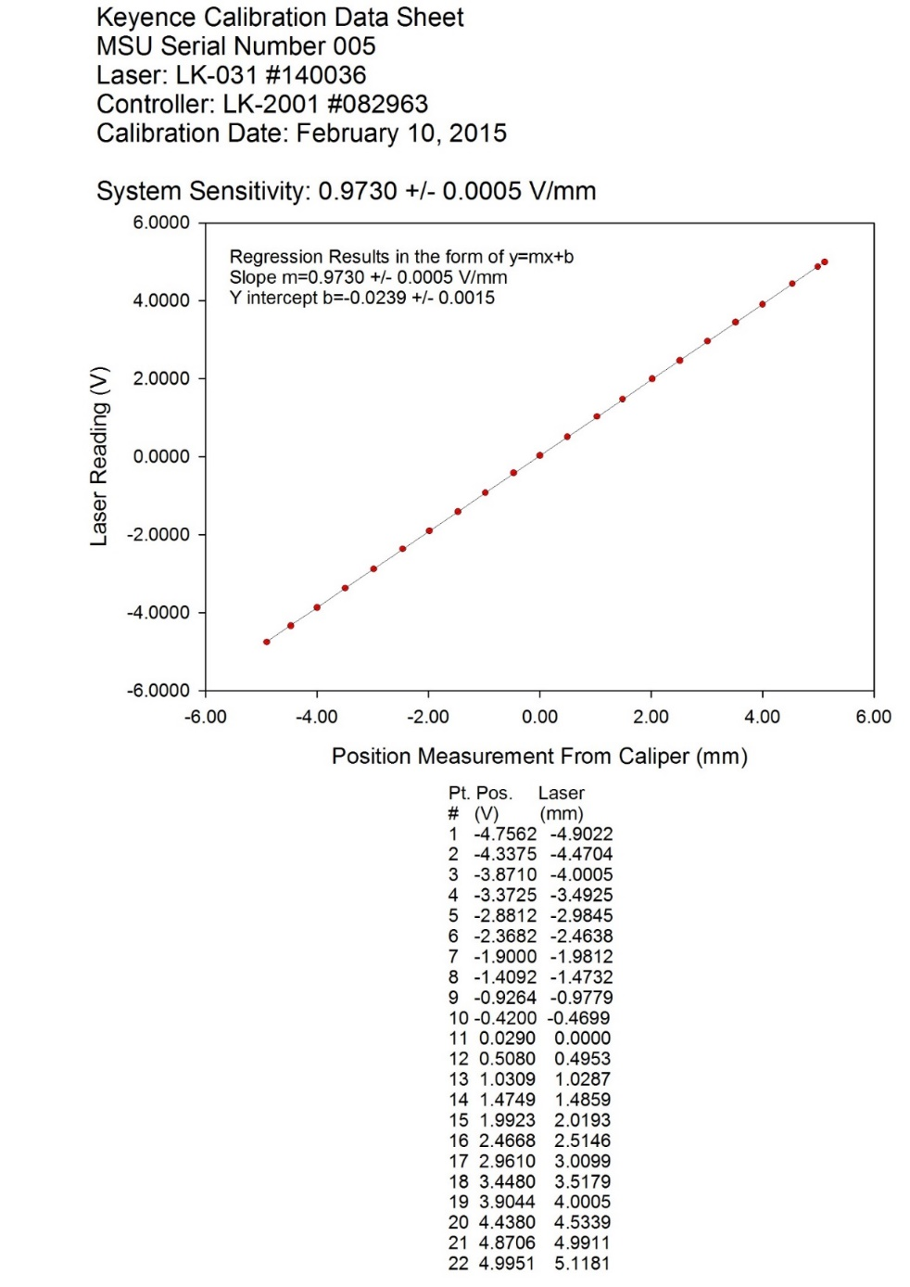

###### Calibrating the digitizer:

This one is also important. It is insufficient to simply use math, the number of bits, and the published voltage reference to calculate the digitizer gain. Although sufficient for approximation, the digitizer gain may vary by several percent around the theoretical value. That inaccuracy will directly influence any calibration that we attempt. Additionally, if there are any amplifiers in the circuit, these will also influence the gain of the channel. Therefore, it should be a standard practice to install a precision DC voltage reference to each channel of the digitizer at the start of the calibration in order to precisely measure the DC offset in terms of counts. I recommend that a +- 1 volt DC signal be applied to each channel. The result should be a measure of counts per volt. In the case of a 24 bit digitizer, if this gain is divided by 1E-6, the inverse of the result will be expressed in terms of microvolts/count. This will enable us to make an accurate measurement of the signal coil output, as well as accurately measure the laser position sensor voltage that represents mass displacement.

###### Laser measurement point versus center of mass:

When calibrating a seismometer, we must measure the mass displacement with the laser, as defined by the *center of mass* of the pendulum. Since this is not always possible because of seismometer geometry, we sometimes are forced to place the laser at some other point along the moment arm, and use geometry to create a correction factor that represents a ratio between the distances of center of mass divided by distance to the pickup point. The distance to the center of mass for a given seismometer is best measured within a laboratory. However, once measured, it should not vary significantly from one seismometer to another of the same given model. We have measured the distance to center of mass for the SM-3 seismometer, but have had to use a “best estimate” for the SKM-series. Other seismometers, such as the S1-P and the Vegik, have geometries where the laser measurement point is placed at the mass center. In those cases, the correction factor is 1.

Thus, these are the critical parameters which must first be known before an accurate calibration of the seismometer is possible:

* Volt meter used for calibrating equipment must be accurate.
* Signal generator must produce strong, stable signals
* Laser position sensor must be calibrated & verified to units of mV/micron
* Each digitizer channel must be calibrated to determine gain in uV/count
* Ratio of distance to center of mass/distance to pickup point.

Once these parameters are measured, we will be ready to begin calibration of the seismometer itself.

# The Calibration Process

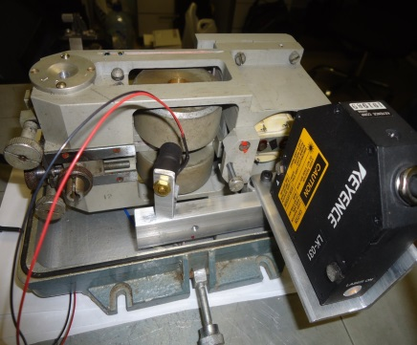Our field calibration method is designed for use with digitally recorded, non-force feedback, electro-mechanical seismometers. The method employs a laser measurement system (Figure 1), a calibration coil ( Figure 2), and a basic signal generator. It can be used where seismometer output is in velocity and mass motion can be observed by the measurement system. Python-based software is used to process the digital data and calculate a poles & zeros description of the instrument response. Using this method, we have calibrated vertical and horizontal instruments such as the SKM, SM-3, VEGIK , and S1-P seismometers.

We developed this method to enable networks a way to accurately and cost-effectively calibrate an electro-mechanical sensor equipped seismic station on-site, with minimal additional equipment cost. By creating a known and accurate calibration, station data may then be used confidently for modern analysis needs. This method may also offer networks a way to expand their station coverage by re-purposing older, but still fully functional seismometers.

## How it works:

For pendulum seismometers, it is possible to determine the ratio*, A*, of the mass motion to true ground motion at frequency, *ω,*  where oscillation frequency (inverse of free period), *ωo* and damping ratio, *h*, are known, using:

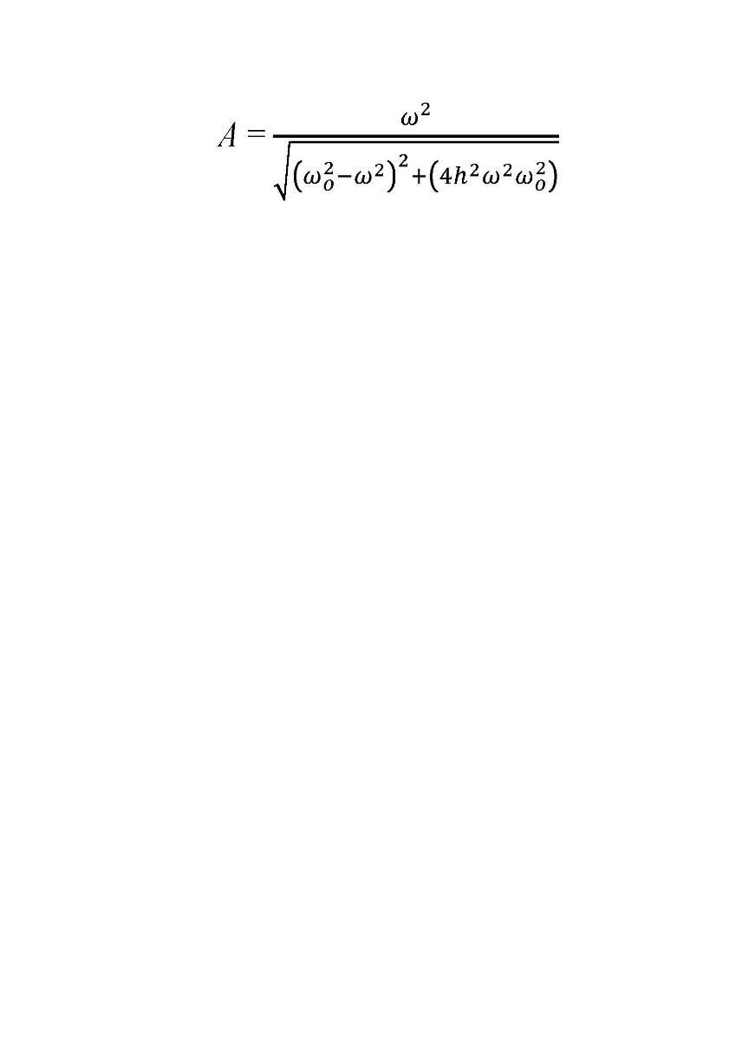

Using this relationship, at any arbtirary frequency, if the seismometer mass displacement is known, it is a matter of basic calculation to determine true ground motion at that frequency. If we excite the seismometer mass at several discrete frequencies that span the operating range of the instrument, we can construct a complete calibration curve for a seismic station. If we know the ground displacement at each fixed frequency, we can calculate ground velocity, which is the mathematical derivative of displacement. If we know the voltage output from the seismometer at that frequency, we can then determine the seismometer voltage output versus ground velocity at that particular frequency. By stepping through several frequencies across the instrument pass band, we can thus construct a curve of points representing instrument response in terms of volts per meter/second. We then fit these points via a grid search algorithm to a poles & zeroes curve. Finally, we store the poles & zeros to a SAC poles and zeros file.

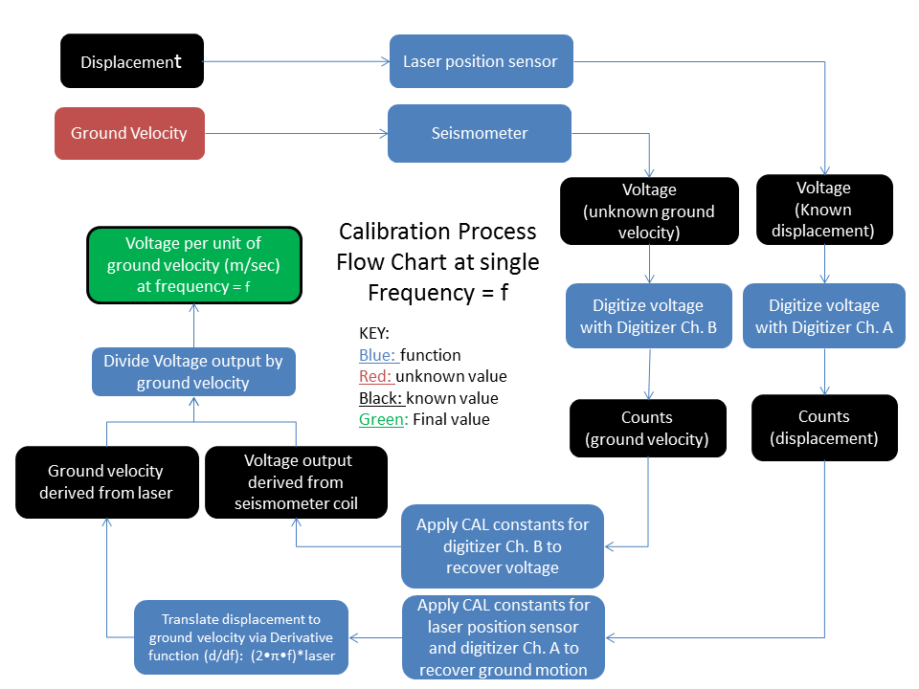

### The calibration process in schematic form.

If we measure the mass displacement in parallel with the voltage output of an electromechanical seismometer at a single sinusoidal frequency, we can determine the voltage per unit of ground velocity at that particular frequency. If we repeat this process at frequencies throughout the passband of the seismometer, we can re-create the response curve for the instrument.

## First step: Generating the data

When first configuring the digitizer for generating data, please be sure to choose a sample rate that is at least 10 times higher than the highest calibration frequency; 20x oversampling is preferable in order to adequately capture the tops of the sine wave. Set the file size such that the data is stored in one-minute files; or as close as you can get to that size.

Secondly, be sure that the digitizer has channel names assigned properly, as the calibration software will reference these names when selecting the data for analysis. In general, one of the channels must be assigned for use with the laser position sensor. A suggested name for the laser channel would be the model of the laser, such as the LK031 or the LKG32.

Finally, the software will work with SAC files, Miniseed, or CSS files. There is also a converter utility that can convert Symmetric Research DAT files to SAC for analysis. Your digitizer will have to be able to provide data output in one of these formats, or else you must supply a data converter and convert it to one of these formats.

Once you have recorded your channel names, channel gains, laser position sensor sensitivity, and configured the digitizer, you should be ready to calibrate the system.

### Initiate a free-period resonance

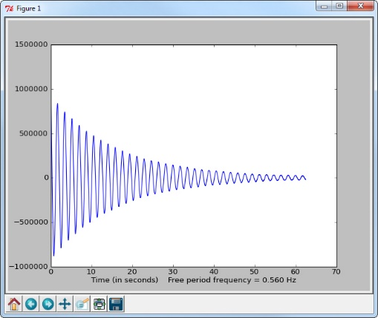The first step is to first characterize the resonance frequency of the seismometer. This is accomplished by first disconnecting all electronic damping from the seismometer. Once the system damping is disconnected, just lightly blow or tap on the mass to place it in resonance. Let the system resonance decay until you no longer can see movement in the mass, and let the digitizer finish filling in the file. Once the file is finished recording, re-connect the damping circuit. Record the name of the digitizer file for future reference as we will need to isolate it when it is time to measure & analyse the free period frequency.

###### Regarding damping within the free-period resonance test

Understand that not all damping is due to the damping coil: There is also mechanical damping due to energy loss from air movement and friction, as well as electrical damping from the signal coil itself. This damping can be substantial, especially in cases where the digitizer has been engineered with a low input impedance. It may be worth measuring the resistance across the open input terminals of the channel on the digitizer. If the measured value is significantly below 1 Mohm, it is possible that the digitizer itself may play a part in the damping of the system.

### Initiate a series of damping ratio impulses

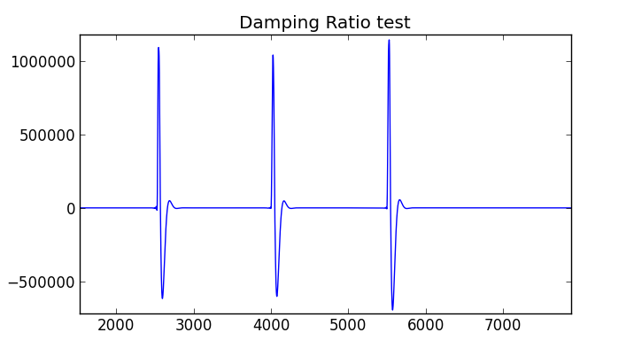The next step is to re-connect the electrical damping and create four of five impulses that will be analyzed in order to determine the system damping ratio. Just gently disturb the mass, then let it dampen out for ten seconds, followed by an additional perturbation. Continue until there have been four or five “bumps”. Record the name of the digitizer files that contain these impulses for future reference as we will need to isolate them when it is time to measure & analyze the damping ratio.

#### Generate the sine waves

The calibration requires us to create a series of data files in which ONE SINGLE frequency for mass excitation exists in each file. In order for this to occur, we will switch to a new frequency once every other file. If the digitizer is configured to store data in 30-second segments, we can shift frequencies once per minute. We will then discard the data files in which the frequency shift occurs, so that the remaining files contain a stationary record of seismic mass displacement and seismometer signal response at that discrete frequency. These series of files will then be analyzed to determine the seismometer frequency response over its entire bandwidth. It is important to get a good statistical sampling of the waveform by sampling at least 15 periods.

Here is a list of suggested frequency break points for this test:

* 0.1 Hz (10 seconds) (Store two minutes worth of time-history for this test)
* 0.2 Hz (5 seconds) (Store two minutes worth of time-history for this test)
* 0.4 Hz (2.5 seconds) (Store one minute worth of time-history for this test)
* 0.6 Hz (Store one minute worth of time-history for this test)
* 0.8 Hz (Store one minute worth of time-history data)
* 1.0 Hz (Store 30 seconds worth of time-history data)
* 1.5 Hz (Store 30 seconds worth of time history data)
* 2.0 Hz(Store 30 seconds )
* 2.5 Hz
* 3 Hz
* 4 Hz
* 5 Hz
* 7 Hz
* 10 Hz

These breakpoints should give us a good description of instrument response over the course of the entire useful bandwidth of most short-period seismometer models. The list is weighted close to the resonance frequency of most electromechanical seismometers. If your model has an unusually high or low resonance frequency, you may wish to tailor the list to your needs by choosing different breakpoints. Additionally, note that the frequencies chosen are arbitrary, and the analysis code will determine the frequencies from the data itself. Therefore, the frequency generator can be set to a slightly higher or lower frequency than the breakpoint; just so long as it is left at that frequency during data acquisition in order to generate the necessary stable (stationary) waveform.

## Second step: Clean and organize the data files

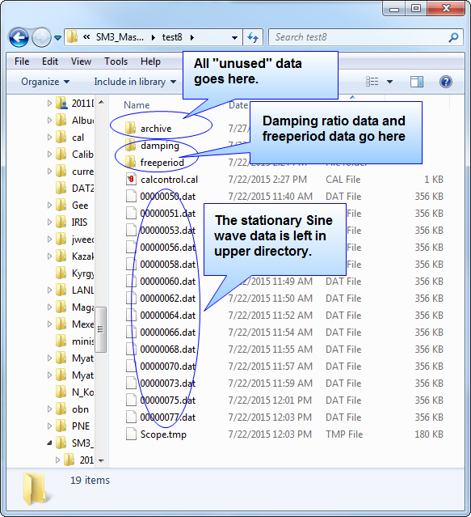Once the damping ratio data, free period data, and sine data have been generated, it must be organized in the working directory. I suggest that you place the data in an easy-to-access directory, such as:

C:\seismo\working

Move all non-essential data to the archive subdirectory that you have created. Move the data file representing the damping ratio to the damping subdirectory. Move the freeperiod data to the freeperiod subdirectory. Leave the data that represents the stationary sine data in the main working directory. Of course, some data formats such as CSS also include an auxiliary file like wfdisc. You will have to manage these auxiliary files accordingly.

LIST OF COMMANDS FOR PROCESSING THE DATA:

**Calcontrol :** This important command will create the control file that governs the processing of the signal data. It provides the channel names, channel gains, and information about the laser and seismometer necessary for proper processing of the data.

**Dampingratio :** This command processes a series of impulses for easily calculating damping ratio. It produces a mean damping ratio that is generated from multiple rebounds from multiple impulses.

**Dat2sac**  : This command is used for converting lists of .DAT files that were generated by the Symmetric Research USB4CH digitizer. This is the digitizer commonly used here at Michigan State University in our seismic department. If your digitzer can output directly to SAC, Miniseed, or CSS you will not need this converter. If not, you will need to find a conversion utility for your data.

**Freeperiod :** This command processes a file with a fourier transform analysis to accurately calculate the resonance frequency of the mass when all electronic damping is removed.

**Sacdisplay** : This command is commonly used when calibrating the digitizer channel with a simple battery and a volt meter. The volt meter yields the actual input voltage, and the Sacdisplay displays the data waveform in order to measure the counts of the digitizer which represent the voltage. The program also is helpful in visualizing the contents of the SAC waveform.

**Sigcal** : This command will process the signal data and calculate a sensitivity curve for the seismometer. It will also output a response curve and generate a SAC poles & Zeros file that describes the response of the instrument.

Run each command within the working folder where your target data resides.

## Third step: Convert the data

Some digitizers already output the data in a compatible format, such as CSS, Miniseed, or SAC. These digitizers will not require file conversion. However some digitizers output a non-standard data format. Because there are so many alternate formats, it is beyond the scope of this user manual to cover them all. However there are two formats specific to a common digitizer that we run across, and that is the Symmetric Research series of USBxCH and PARxCH digitizers. We have created a Python script that converts the data from the Symmetric Research .DAT format to the more standard SAC binary format. You may already have other converter utilities that accomplish a similar task for other digitizer models.

### Converting the Symmetric Research data:

This example uses the USB4CH model of digitizer that outputs a data file format named .DAT . In this case, the working directory has been populated with data from a test SM3 seismometer. The utility for converting the data is called “**dat2sac**”. We therefore run this utility three times: Once on the stationary sine data, once on the free period data, and once on the damping ratio data. The script will parse through the directory and convert each file. Go to the target directory and type ‘dat2sac’.

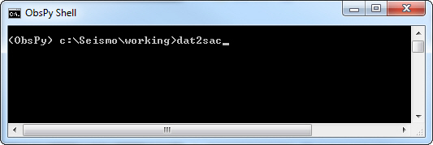

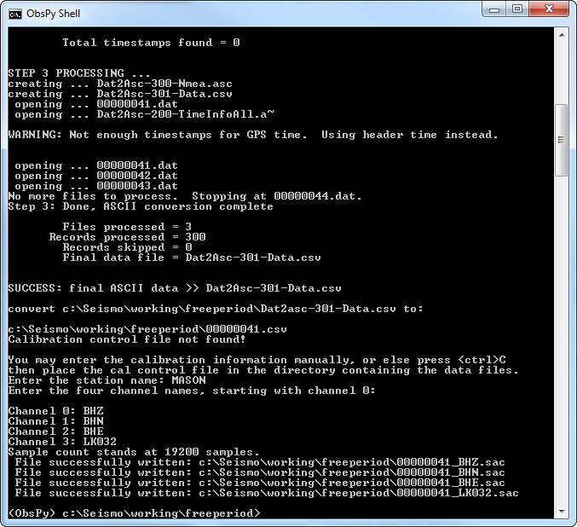The converter will parse through the directory and start converting all DAT files to a .csv ascii file. At the same time, it will also convert the data to SAC file format.

However, before this can happen, we must provide the converter with some information about the data, such as the station name and channel name.

Once you have converted the main stationary data, go to the free period and damping ratio directories, and repeat this procedure, taking care that the station and channel name assignments are identical.

## Fourth step: Process the free period and damping ratio data

At this point, we should have cleaned and converted the data (if necessary). We should have calibrated our laser position sensor, and our digitizer. We should have our station name, and our channel names. We have collected our raw calibration data. We should now be able to begin processing to characterize the seismometer behavior in terms of free period (inverse of resonance frequency), and damping ratio.

### Free period

With the command line prompt open, go to the free period folder and type “freeperiod”. If you are using a non-SAC file format, type in the format type as an option. (SAC, CSS, MSEED)

#### Free Period command syntax:

C:\Cal\freeperiod> Freeperiod c:\cal\freeperiod\201509023*.sac sac [css] [mseed]

Command requires file name containing data, as well as alternate file type, if not sac.

Note the use of the wild card to import all SAC files.

For css, point the program at the .wfd file within the css directory, and edit the .wfd to show only the files containing the free period data waveform.

For miniseed, use the wild card designator similar to the SAC file reading format.

#### Free Period Example:

Follow the on-screen directions, and designate the name of the channel to which the laser position sensor and the seismometer signal coil are connected. Free period will then bring up a plot of the signal coil channel. Place your cursor onto the waveform where it is stable and un-clipped, and write down the sample number, which is shown as the ‘x’ coordinate of the plot.

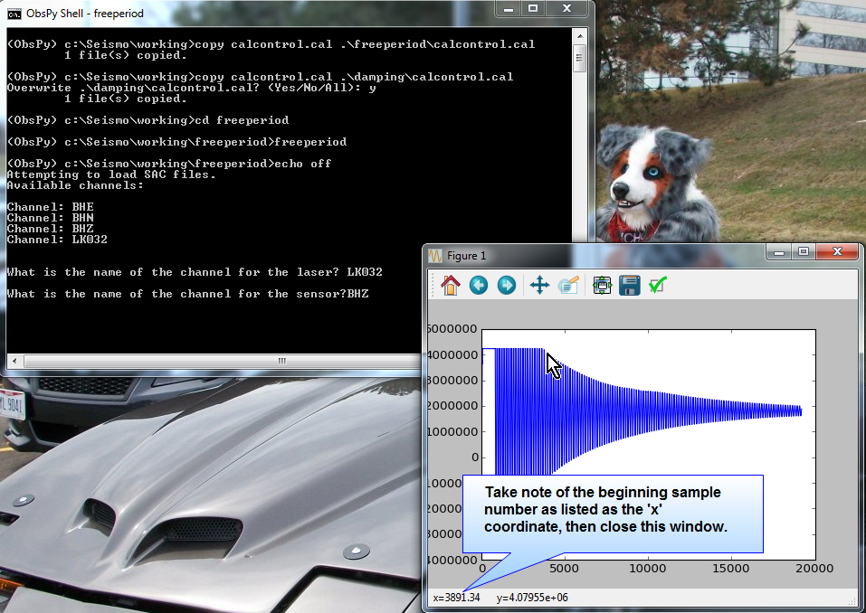

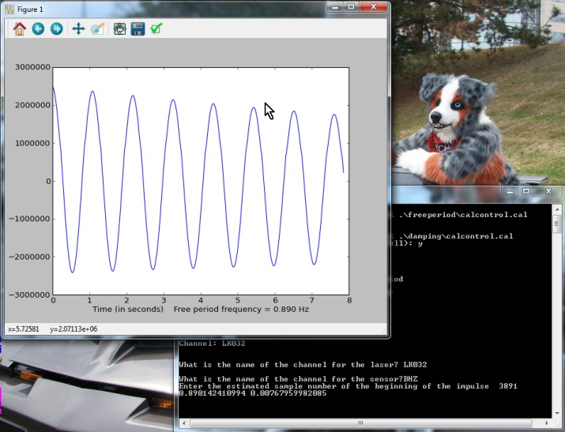Next, close out the window, and provide to the program the sample number with which to begin the analysis. Freeperiod will then analyze the waveform, beginning at that sample, with a fast-fourier transform to statistically determine the frequency with the highest energy in the spectrum. This yields a highly accurate measure of the resonance frequency, which is then reported on the next pop-up window. Click on the “floppy disc” icon, and save this graph to your computer for your documentation.

(Note: In this example, free period calculates out to 0.890 Hz)

### Damping Ratio

With the command prompt screen open, go to the damping subdirectory where the damping ratio data is located, and type “dampingratio” to launch the python script that analyzes for damping ratio. If you are using a non-SAC file format, type in the format type as an option. (SAC, CSS, MSEED)

#### Damping Ratio Command Syntax:

C:\Cal\dampingratio> dampingratio c:\cal\dampingratio\201509024*.sac sac [css] [mseed]

Command requires file name containing data, as well as alternate file type, if not sac.

Note the use of the wild card to import all SAC files.

For css, point the program at the .wfd file within the css directory, and edit the .wfd to show only the files containing the free period data waveform.

For miniseed, use the wild card designator similar to the SAC file reading format.

#### Damping Ratio Example

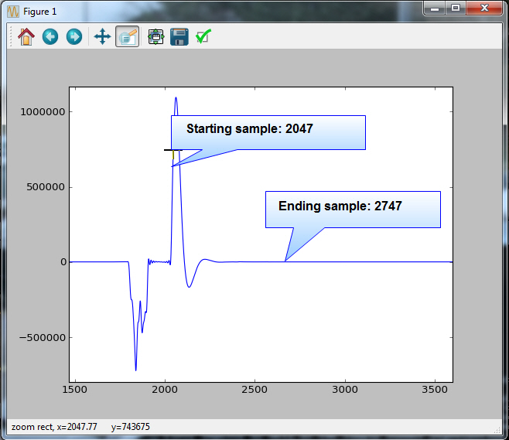Using the first window, use the cursor to find the starting and ending sample numbers that bracket the damping ratio impulses. There should be multiple impulses within the window. You can use the “zoom to rectangle” function at the top of the screen to zoom in on the impulses, like I have done for this figure. Continue through all of the displayed impulses, recording the starting and ending sample numbers until all impulses have been analyzed. Note that ending sample is arbitrary, but it is important that you choose a sample number where the waveform is stable near zero, and before any activity from the next impulse.

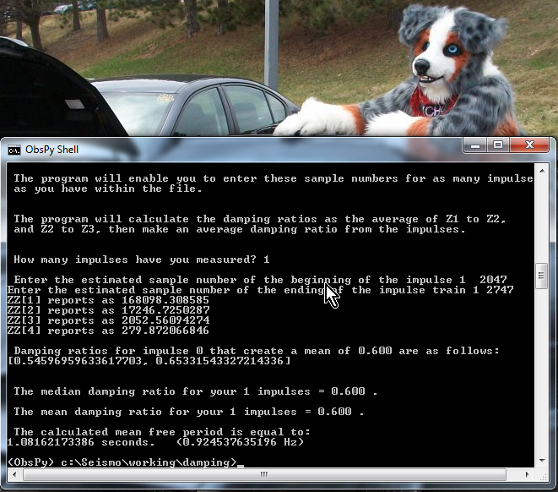

Once you close the first window, the code will ask you how many impulses you have measured, as well as the starting and ending number for each impulse. The damping ratio is a measure of the amplitude of each subsequent rebound relative to the previous rebound. Therefore, some statistics are calculated for the rebounds. If the median and mean damping ratio are close in terms of value, then your test impulses are likely good. Record the mean damping ratio, as it will be used in the next step for generating a calibration control file.

##### Alternate free period:

Note that the damping ratio program also calculates an “effective” free period. Is is calculated from the duration of time between the impulses. This is based on the calculation of free period as found within Soviet instrumentation literature using the following formula:

Free-Period (in seconds) = $Ts^{'}•√\left(1-h^2\right)$ where, Ts’ = time between impulse peaks and h = damping ratio.

This alternate free period is generally found to be within ten percent of the measured free period. There is debate as to which one is the most appropriate for use.

## Fifth step: Generating the calibration control file

### Calibration control file description

The next step to calibration is the generation of a control file. This is the file that gives the necessary information to the analysis program required for proper calculation of the instrument response. This file is a plain text document that we will generate using a utility called “calcontrol” from a command line prompt.

### Calibration control example

Note that in the example below, these are the sample values. When calibrating three components of the same station, you may use this same file, but you will have to edit the file in a text editor to change your measured damping ratio, resonance frequency, and channel under test assignment.

**MSU,BHZ,BHN,BHE,LK031,**laserres,lcalconst,h,resfreq

MSU,**0.9413,0.9425,0.9425,0.9442,0.9932,0.579,0.707,0.824**

**0,3**

**This calibration control file represent sample parameters.** **Your particular file will likely have very different values than this, depending on the make and model of your seismometer and digitizer.**

Station name: MSU

Channel 0 = BHZ, with a channel gain of 0.9413 microvolts per count.

Channel 1 = BHN, with a channel gain of 0.9425 microvolts per count.

Channel 2 = BHE, with a channel gain of 0.9425 microvolts per count.

Channel 3 = LK031, with a channel gain of 0.9442 microvolts per count. (laser channel)

Laser position sensor gain(laserres) is 0.9332 mV/micron.

Laser measurement point to mass center ratio(lcalconst) = 0.579 (This is the constant for the SM3. Other seismometer models will use a different ratio.)

Initial damping ratio (h) = 0.707

Resonance frequency (resfreq) = 0.824 Hz. (Remember though – these are just sample numbers.)

Channel under test vs the channel assigned to the laser: 0,3

In this case, the channel under test is channel 0: (BHZ), and the laser is assigned to channel 3: (LK031)

### Calcontrol

Calcontrol provides the constants necessary to determine signal coil voltage, displacement, channel name, the laser calibration, and the seismometer physical characteristics. In order to generate this file, open the command prompt, and go to your working directory in which you will place your calibration data. It is essential that this data be accurate in order to get an accurate calibration.

#### Calcontrol command syntax

C:\seismo\working> **calcontrol**

There are no optional command line switches. Run this command from within the working directory that contains your calibration data.

#### Calcontrol Example:

Follow the command prompts to fill in the appropriate information. Use the computed damping ratio and free period from the previous steps. Once finished, a control file will be created that will control how Sigcal processes the calibration data. Make sure that this calibration control file is present within the working directory.

The program will prompt you for information on the four ADC channels in terms of channel name and channel resolution. There are default parameters that will load: If you wish to accept the default, press the enter key. Note that these paramters are very likely to NOT be accurate the first time you run the code, but you will have a chance to save your settings as the new default parameters. This is a handy time saver when recalibrating the same station.

## Sixth step: Analyzing the stationary sine data

### Sigcal analysis program

Sigcal is the analysis code that uses the cal control file and the sine-wave data for resolving instrument sensitivity. Each file within the sine data should contain a waveform representing a voltage output from the signal coil, and a waveform representing the related pendulum displacement, as measured by the laser.

#### Sigcal command syntax:

C:\Seismo\working>sigcal [directory or css filename] [filetype]

Optional command line parameters are the type of file to be analyzed. SAC is the default. If your file type is different, you must specify it here. The choices are:

sac

mseed

css

csv

If you are using a css format, you must specify the file name containing the css file list.

While in the command prompt window, go to the working directory and type “sigcal” to start the analysis program. It should begin searching the directory for SAC files. As an alternative, you can use CSS files by typing “sigcal css”. Other types of file formats that are supported are the Symmetric research csv ascii format “sigcal csv”), and the miniseed format (“sigcal msd”).

Sigcal will search the working directory and bring in all data files. It will then signal process each file to determine the sensitivity of the seismometer at each discrete frequency it finds within the data. It will then output a file called “calibration_output.cal” containing the sensitivity data points. Lastly, Sigcal will use the output to generate a SAC poles & Zeros response file that represents the best-fit to the data.

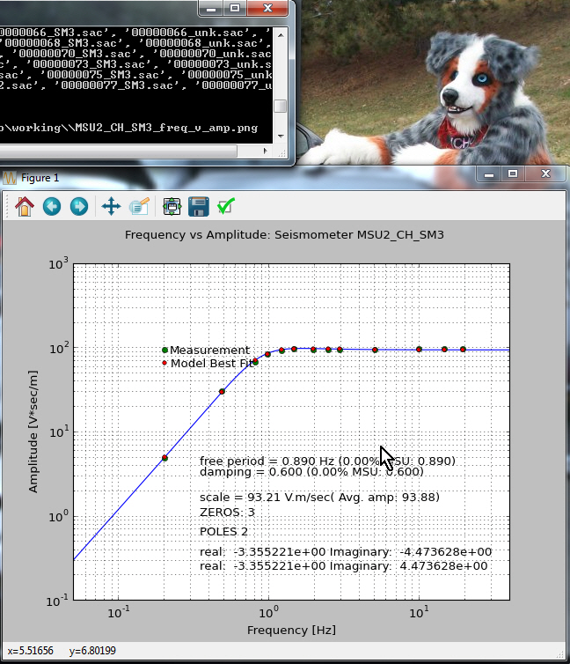After the processing, Sigcal will search the parameters and plot the response of the instrument. This plot will plot in green dots the actual measured response and then overlay red dots that represent the intersection of the theoretical response as calculated by a poles & zeros description. Two files are saved automatically in the working directory: The SAC poles & zeros file, and the plot as shown on your screen.

At this point, the seismometer now has a full bandwidth description of its response and a calibration. Save and print this graph as a measure of the calibration, and make sure it is annotated with the network name, station name, channel name, and date of calibration.

### Documentation

The calibration is helpful only if is it accessible by the users of the data. Therefore careful consideration as to the storage of the records is important.

Once the data is processed, copy the entire contents of the directory to a calibration archive that is named for the network, station, channel, and calibration date.

As an example, if the network is US, and station is MSU, and the channel is the vertical, we might name the directory thus:

C:\seismo\cal\US_MSU_BHZ_20150724

### Distributing the calibration

Next, ensure that a copy of the graph contains the essential information such as today’s date, the station name, and the channel name. Then, ensure that the SAC poles & zeros file, along with the plot are available and distributed to the users of the data. This information is essential for analysts who might employ seismic analysis tools such as synthetic seismograms, forward modeling and inverse modeling. It enables researchers to mathematically remove the effect of the sensor from the data.

COOK BOOK FOR PROCESSING THE CALIBRATION DATA

Here is a bulleted list of the steps necessary for processing a calibration for a single seismic channel. Note that this list calls out a converter for the Symmetric Research USB4CH. If your system already outputs SAC, CSS, or Miniseed, your procedure will be slightly different in that there will be no need for the converter step.

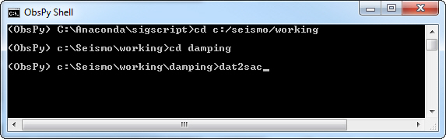

1. Navigate to [Damping] folder in command prompt :
2. cd c:\seismo\working\damping
3. Type ‘DAT2SAC’ to convert data
4. Type ‘Dampingratio’ to initiate damping ratio calculator

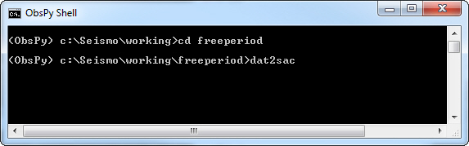2. Navigate to [freeperiod] folder in command prompt

1. cd c:\seismo\working\damping
2. Type ‘DAT2SAC’ to convert data
3. Type ‘FreePeriod’

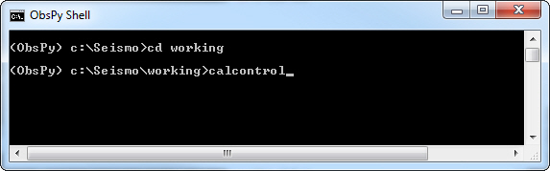

3. Navigate to [working] folder in command prompt

1. cd c:\seismo\working
2. Type ‘Calcontrol’ to create the calibration control file
3. Type ‘DAT2SAC’ to convert data
4. Type ‘SIGCAL’ to analyze the data and create a plot and a SAC calibration file.

# Кулинарная книга для обработки данных калибровки

данных книги здесь это маркированный список шагов, необходимых для обработки калибровки для одного сейсмических канала. Обратите внимание, что этот список взывает преобразователь для симметричного USB4CH исследований. Если ваша система уже выводит SAC, CSS или Miniseed, процедура будет немного отличаться в том, что конвертер шаг не потребуется.

1. Перейдите в папку [демпфирования] в командной строке:
   1. cd c:/seismo/working/damping
   2. типа 'DAT2SAC' для преобразования данных
   3. типа 'Dampingratio' инициировать демпфирования калькулятор коэффициент
2. Перейдите к папке [freeperiod] в командной строке:
   1. cd c:/seismo/working/damping
   2. типа 'DAT2SAC' для преобразования данных
   3. типа 'FreePeriod'
3. Перейдите к папке [работаем] в командной строке:
   1. cd c:seismo/working
   2. типа 'Calcontrol' для создания файла c калибровки управления)
   3. тип 'DAT2SAC' для преобразования данных
   4. типа 'SIGCAL' для анализа данных и создать сюжет и файл калибровки SAC.

# Sigcal calibration worksheet

Network name: ____________ Station name:________________ Channel name:____________

Seismometer model: ______________ Vertical/Horizontal: ________ Serial#: ________________

###### Digitizer information

Digitizer model:___________________ Serial # __________________ total # channels: _________

Calibration date: __________________

Digitizer channel 1 input sensitivity: ______________ uV/count Connected to Channel: ___________

Digitizer channel 2 input sensitivity:______________ uV/count Connected to Channel: ___________

Digitizer channel 3 input sensitivity:______________ uV/count Connected to Channel: ___________

Digitizer channel 4 input sensitivity:______________ uV/count Connected to Channel: ___________

Digitizer channel 5 input sensitivity:______________ uV/count Connected to Channel: ___________

Digitizer channel 6 input sensitivity:______________ uV/count Connected to Channel: ___________

###### Laser position sensor information

Laser position sensor model:______________ Serial#___________________

Calibration date: __________________

Laser position sensor sensitivity: ___________ mV/mm of displacement

###### Geometry of laser vs. center of mass

Geometric ratio of length to center of mass vs length to laser measurement point: ___________

###### Seismometer operating characteristics

Seismometer resonance frequency: __________ Hz Damping Ratio (h) : ______________

Digitizer channel that is connected to this seismometer*: __________

Digitizer channel that is connected to the laser position sensor*: __________

* This information is found in digitizer information listed above

Calibration performed by: ____________________ on this date: ______________________